Date: 21.03.2025
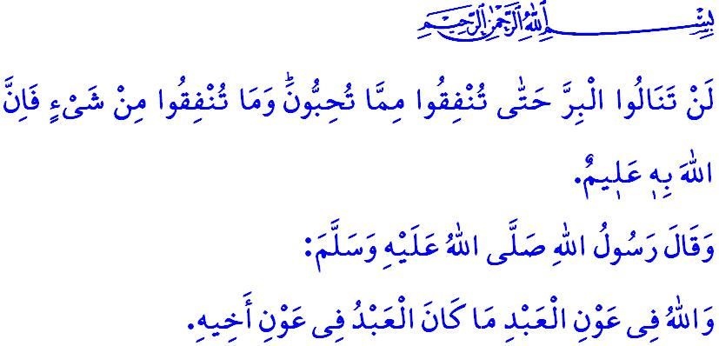
RAMADAN: THE MONTH OF INFAQ AND THE QUR’AN
Honorable Muslims!
We are in the last ten days of the holy month of Ramadan. These days are the days of i‘tikaf. As reported by our mother A’isha, the Messenger of Allah (saw) used to observe i‘tikaf during the last ten days of Ramadan, and we should seek Laylat al-Qadr in the last ten days of Ramadan. I‘tikaf is one of the sunnahs of Ramadan. It provides us with the opportunity to dedicate the last days of Ramadan to worship and reflection, sincere repentance, praise and gratitude, supplication, and remembrance of Allah.
Dear Believers!
Once, Abdullah (ra), the son of our Prophet's (saw) uncle Abbas, observed i‘tikaf in Masjid al-Nabawi. During those days, he saw a man entering the masjid with a sorrowful expression. When Abdullah learned that the man was distressed due to an unpaid debt, he said, “Let me speak to the person to whom you owe the debt.”, and left the masjid. The man said, “O Abdullah! Have you forgotten that you are in i‘tikaf?” Abdullah (ra) replied, “I heard our Prophet (saw) say, ‘Whoever strives to fulfill the need of his Muslim brother, it is better for him than ten years of i‘tikaf.’“
Esteemed Muslims!
The spirit of helping one another comes on top of the values instilled in us by our Prophet (saw). The most essential principle in maintaining this spirit of awareness is infaq. Infaq is the act of sharing both material and spiritual blessings bestowed by Allah, with the sincere intention of seeking His pleasure. It is an effort to spread goodness on earth and eradicate evil. It means being a source of joy and hope for one another, multiplying our happiness through sharing.
Dear Believers!
The path to achieving righteousness lies in infaq. Our Almighty Lord draws our attention to this point by stating, “You will never achieve righteousness until you donate some of what you cherish. And whatever you give is certainly well known to Allah.” Every Muslim, whether man or woman, young or old, rich or poor, has something to give as a form of infaq. Therefore, sharing our zakat and sadaqah with our brothers and sisters in need is a form of infaq, just as expressing love to our spouses, showing compassion to our children, and greeting our parents with a smile are also acts of infaq. Infaq sometimes means providing for our relatives and neighbors or caring for orphans and those in need. At times, infaq involves visiting hospitals, and care and nursing homes to demonstrate our care and affection for our brothers and sisters. At other times, infaq encompasses asking about the well-being of those in need and settling the debts of those who are indebted. Still other times, infaq means helping young people who are unable to marry by supporting them in getting married and establishing a home, or creating employment opportunities so that people can earn a livelihood with dignity. Infaq also means continuing our support for the oppressed, especially in Gaza, and steadfastly upholding our noble stance against the Zionist oppressors and their supporters who perpetrate this persecution.
Dear Muslims!
We live in an age where this-worldliness and individualism dominate our lives, where happiness is pursued through consumption, and where a lifestyle driven by desires and vanity is glorified. In reality, everything we consider our own, whether wealth or possessions, is merely a trust from our Lord. When the time comes, our journey in this world will end, and our possessions will pass into the hands of others. So let us seize the opportunity of Ramadan to strengthen our bonds of brotherhood through infaq. Let us reinforce our unity and solidarity through infaq. Let us deepen our devotion to our Lord through infaq. Let us remember that our support for those in need and for our institutions, especially our mosques, which uphold our social unity, will serve as sadaqah jariyah and as our provisions for the Hereafter. Let us always keep in mind our Prophet’s (saw) hadith: “As long as a person helps his brother, Allah will help him.”
Dear Believers!
Next Thursday evening, we will, inshallah, observe the Laylat al-Qadr. Our Almighty Lord (swt) informs us of the value of the Laylat al-Qadr in Surah al-Qadr as follows: “Indeed, ˹it is˺ We ˹Who˺ sent this ˹Qur’an˺ down on the Night of Glory. And what will make you realize what the Night of Glory is? The Night of Glory is better than a thousand months. That night the angels and the ˹holy˺ spirit descend, by the permission of their Lord, for every ˹decreed˺ matter. It is all peace until the break of dawn.” The Holy Qur’an, which makes Laylat al-Qadr more auspicious than a thousand months, is a divine book that introduces us to our Almighty Lord and teaches us the purpose of existence and life. It is a divine guide that distinguishes between truth and falsehood, right and wrong. It is a divine call inviting all people to the truth and reality. Therefore, let us strive to strengthen our bond with the Qur’an, to be revived and guided by its teachings. Let us shape our lives according to the principles of the Qur’an and the guidance of the Sunnah.

I would like to take this opportunity to congratulate you on Laylat al-Qadr and to pray to Allah the Almighty (swt) that our night would be prosperous for our great nation, the Muslim world, and all humanity.

Bukhari, Fadl al-Lailat al-Qadr, 3.
Bayhaqi, Shu’ab al-Iman, 3, 424.
Ali ‘Imran, 3/92.
Abu Dawud, Adab, 60.
Qadr, 97/1-5. General Directorate of Religious Services

